**Relocating Ocean Bottom Seismographs by Inversion**

Ocean Bottom Seismographs are relocated using the water wave picks identified and picked using the tlPicker. Before proceeding with the inversion results, it’s important to understand the station bathymetry.

*Figure A Figure B*

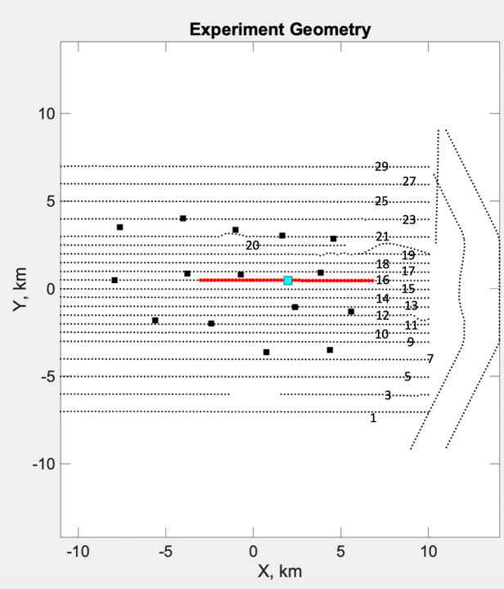The figure A to the left showcases the numbering of the Lines with respect to the station geometry. The red line on this figure is a potion of selected tomography picks along line 16 that are located within a 5km radius of the station 21. The figure B to the right is a representation of all the tomography shots and the respective station locations near the orca volcano.

The figure C below shows this set of water waves generated along Line 16 station 21 as a record section. Each onset of the water waves is denoted by a red line picked by setting the wiggle option to -1 within tlPicker. To generate this record plot, a clip of 1 was used with 1e-05 scale on the channel 3. Using tlPicker, the water wave arrivals originated 5 km laterally from each station were picked and used within the inversion

*Figure C*

The Figure below is the result of the inversion performed on all stations. As shown here, the RMS residuals observed in each station is less than 8 x10-3 seconds.

*Figure D*

The figure E is a representation of how the RMS residuals of change in each station for each constant velocity (1445-1465 m/s) within the inversion. The labels indicate the velocity at its local minimum.

*Figure E*

When visualizing which events are recorded in multiple station the figure F below shows that a significant portion of tomography shots are recorded in 3 or more stations. This allows us to conduct a joint inversion to correct event locations.

*Figure F*

The figure G is a Misfit histogram between the Observed Travel Time and the Predicted trave time for each event used in the inversion. From this figure it can be noted that the errors are gaussian and there are some outliers within the data that needs to be evaluated

*Figure G >*

*

*Figure H Figure I*

The figures H and I above are showing how the best velocity (Determined by Figure E) varies through the station geometry. While we initially hypothesized that the best velocity might vary from east to west, the above figure debunks this to show that the velocity varies pretty randomly across stations.

Figures K denotes which tomography shots are excluded from the inversion while Figure J shows the map view of the histogram figure F. Here, most shots in the mid portion of the station geometry contains 3 or more stations recording the same event. Red dots on figure J are the events which 2 or 1 stations recording them.

Figure J

Figure K

Now that Initial Analysis of parameters are conducted, let’s proceed through the inversion figures that were generated by the obsloc code.